Q1: Convert the ERD given below to relations. Fine anomalies and convert the relations to 2NF, and 3NF.
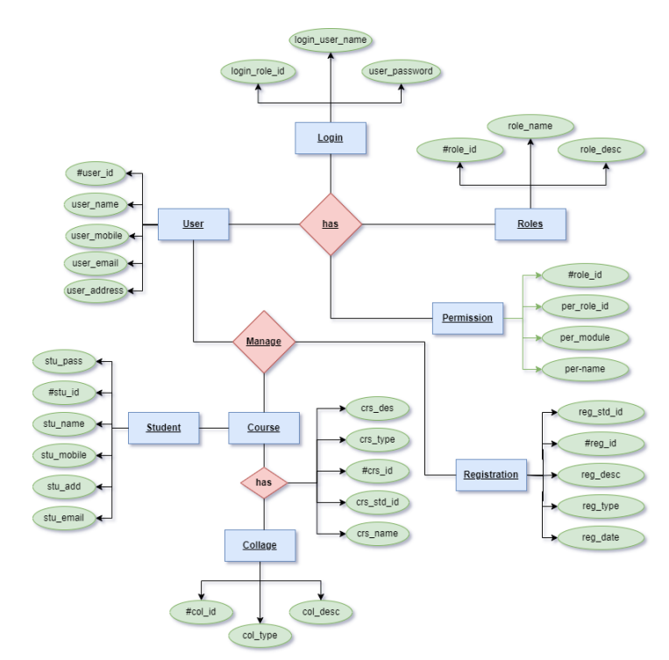

Ans:
